 | APPLICATION FOR  ADMINISTRATIVE APPROVAL | 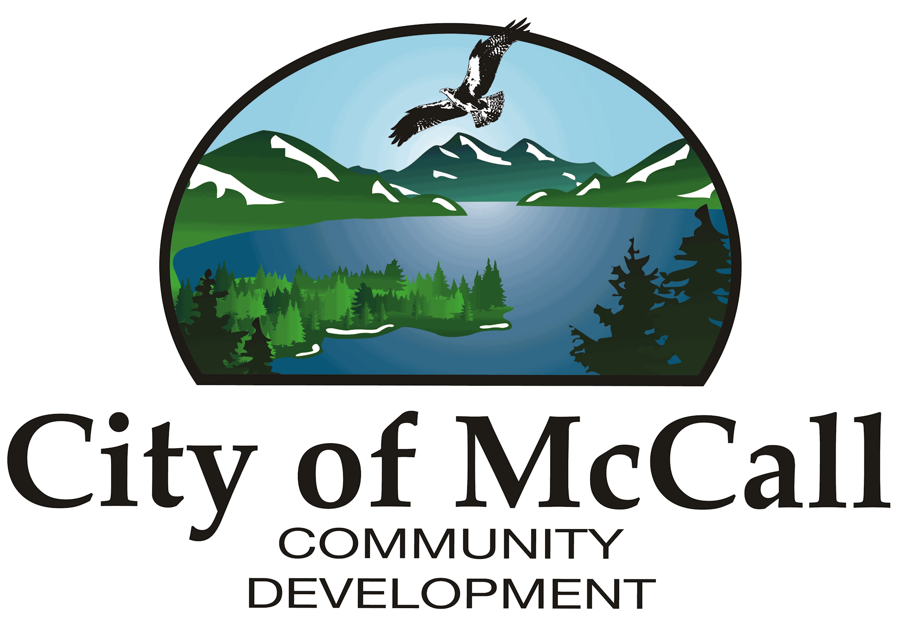
City of McCall | APPLICATION FOR  ADMINISTRATIVE APPROVAL
216 East Park Street | APPLICATION FOR  ADMINISTRATIVE APPROVAL
McCall, Idaho 83638 | APPLICATION FOR  ADMINISTRATIVE APPROVAL
P: (208) 634-7142 | APPLICATION FOR  ADMINISTRATIVE APPROVAL
F: (208) 634-3038 | APPLICATION FOR  ADMINISTRATIVE APPROVAL

PROJECT DESCRIPTION

Required Application ITEMS
Each application packet must contain the following, unless shown and explained otherwise, or exempted in writing by Planning Administrator:
- This Application Form (Hard Copy/PDF Applications are available upon request from plans@mccall.id.us)
- Project Description (Type or write in space provided above)
- General Plans including (Attach as PDFs in the Citizen Application Portal):
  - Lot Size
  - Setbacks
  - Project Square Footage
  - Elevations
  - Vicinity Map
Applicant Agreement
The Applicant agrees, to pay reasonable attorney fees, including attorney fees on appeal and expenses of the City of McCall, in the event of a dispute concerning the interpretation or enforcement of the Design Review Application in which the City of McCall is the prevailing party.

I certify that I have reviewed and understand the procedures and requirements of the McCall Zoning Code. I give permission for City representatives and/or Planning & Zoning Commission members to view and enter the subject property in order to fully review this application. I understand that failure to provide complete and accurate information on this application may lead to denial of this application.

__________________________________________________ ______________________
Signature of Owner or Authorized Representative Date

