 | PLANNED UNIT DEVELOPMENT (PUD) FINAL PLAN  INFORMATION | 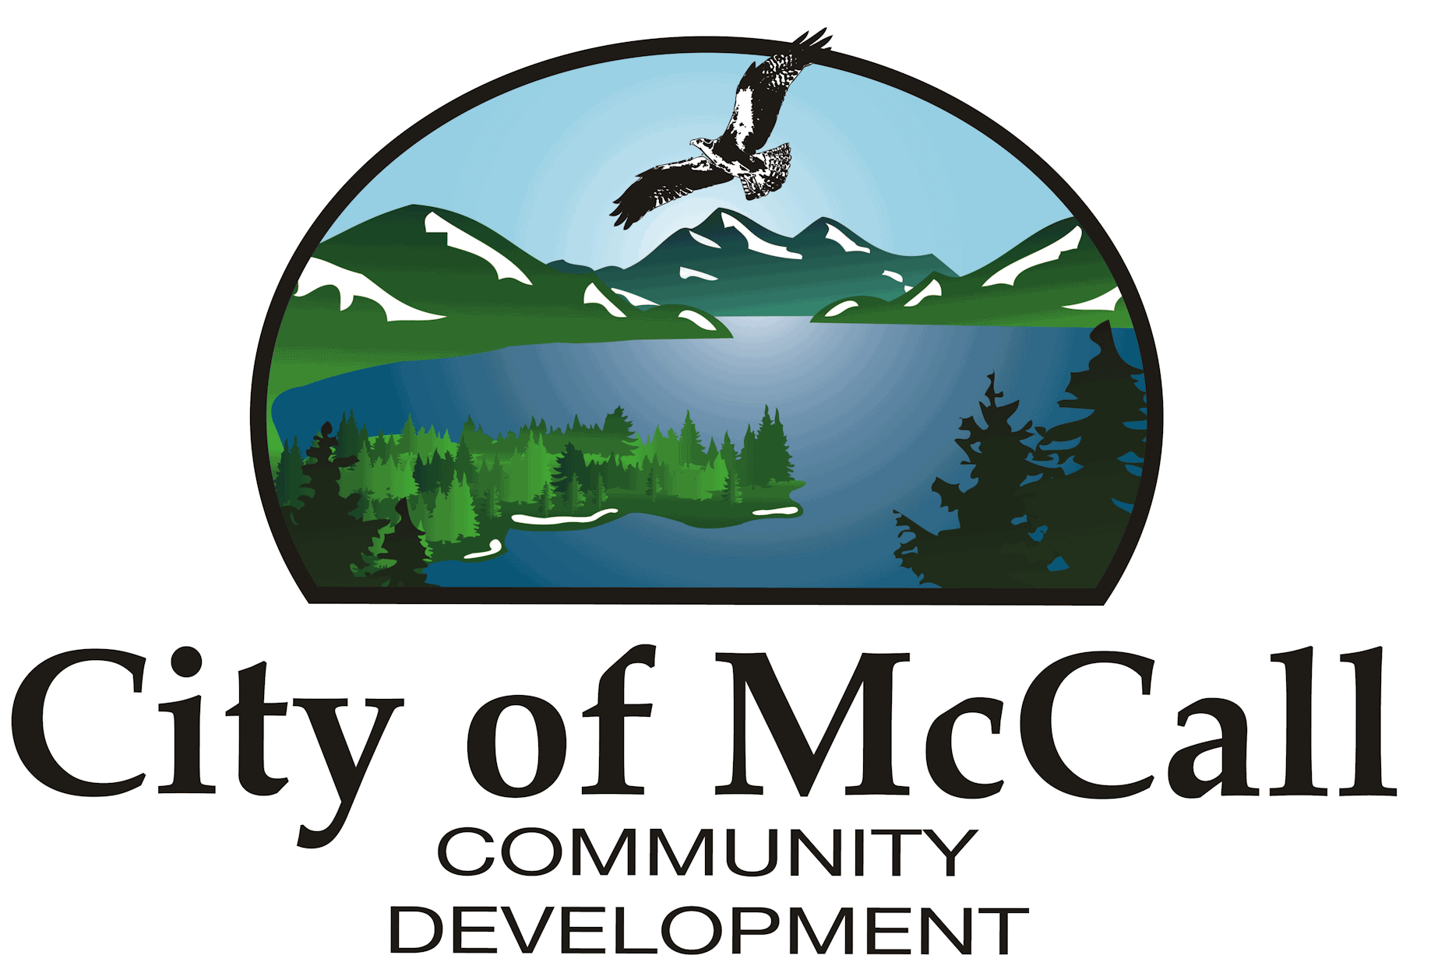
City of McCall | PLANNED UNIT DEVELOPMENT (PUD) FINAL PLAN  INFORMATION
216 East Park Street | PLANNED UNIT DEVELOPMENT (PUD) FINAL PLAN  INFORMATION
McCall, Idaho 83638 | PLANNED UNIT DEVELOPMENT (PUD) FINAL PLAN  INFORMATION
P: (208) 634-7142 | PLANNED UNIT DEVELOPMENT (PUD) FINAL PLAN  INFORMATION
F: (208) 634-3038 | PLANNED UNIT DEVELOPMENT (PUD) FINAL PLAN  INFORMATION

The following information must be submitted with your application:
- Digital files of Final Development Plan documents (PDF preferred, submitted via the McCall Online Application Portal).
- Fee upon invoicing - payable to the City of McCall
- A letter addressing how each condition of approval from the PUD General Plan Approval was addressed (and reference the document).
- Development agreement (use City of McCall template available on the McCall Application Portal under ‘Development Agreement – DA – Template’)
- Electronic files in a form specified by the City
- Improvement guarantee(s) (Escrow Agreement)

Items that shall be included in the final development plan are:
- a. drawings and information. The final development plan shall be drawn in clear and legible form in digital format according to the City of McCall digital submission standards. Upon final approval, the approved plan shall be submitted for signature on good quality tracing paper or Mylar® drafting film at a reasonable size and scale to clearly show all required information.

- b. Information required on the plan. In addition to that required by the preliminary development plan, or otherwise specified by law, the following information shall be shown on the plan:
1) reference points of identified existing surveys related to the
PUD plan by distances and bearings and referenced to field book or map, including stakes, monuments or other evidence found on the ground and used to determine the boundaries of the PUD.
2) the location and width of streets and easements intercepting the boundary of the tract.
3) easements and storm water drainage facilities clearly identified and, if already of record, their recorded reference. The width of the easement, its length and bearing, and sufficient ties to locate the easement with respect to the PUD shall be shown. If the easement is being dedicated by the plan, it shall be properly referenced in the owner’s certificates of dedication.
4) identification of land to be dedicated for any purpose, public or private.
5) other plans and studies as required at preliminary approval such as a grading plan, soils engineer report, traffic study, detailed landscaping and buffering plans where required.

- c. additional certificates or drawings. The following may be combined where appropriate:
1) a certificate signed and acknowledged by all parties having any recorded title interest in the land, consenting to the preparation and recording of the PUD.
2) a certificate signed and acknowledged as above, dedicating the land intended for public use, if any.
3) a certificate with the seal of and signed by the surveyor responsible for the survey.
4) a title report issued by the title insurance company verifying ownership by the applicant of real property that is to be dedicated to the public.
5) a copy of any deed restrictions applicable to the PUD

- d. a detailed design plan for the PUD site including:
1) the location of proposed buildings and structures, parking and maneuvering areas and/or the location of allowable building areas of individual lots, if any.
2) building setback lines, if any, that are to be made part of the PUD restrictions.
3) the location and type of proposed buildings, structures or improvements in common open space areas.
4) the location and detailed information for all proposed streets, with approval by the City for public streets and fire marshal for private streets.
5) a plan for water mains approved by the City and fire hydrants approved by the Fire Chief.
6) a plan for sanitary sewer approved by the City.
7) a plan for storm water drainage with approval by the City.
8) plans for additional improvements such as pedestrian ways, street lighting, public utilities, street trees, etc.

- e. A landscaping and buffering plan for common open space areas, the periphery of the PUD and other required locations. The plan shall show area to remain in natural vegetation; and, in a clear manner, the area, sizes, numbers and general types of plant and other materials to be used. Revegetation of common open space areas and periphery areas disturbed during the construction of services, dwellings or other facilities proposed during the construction schedule, if cannot be completed prior to occupancy of dwellings or as otherwise required by the conditions of approval, an improvement guarantee of a sufficient amount shall be required to assure timely completion.

- f. The subdivider shall submit in final form any restrictive covenants or conditions that shall be applied to the subdivision, including architectural or design controls, organization of a Homeowners’ Association, assessments, various Homeowners’ committees, easements, and a legal description of the property. Also to be submitted, if required, are the final Bylaws and Articles of Incorporation of the Homeowners Association.

Procedure:
Within one (1) year after approval of the preliminary development plan, the applicant shall submit to the City a final development plan for the entire PUD or a final development plan for the first phase of development if the PUD has been approved for phased development. The applicant shall submit final development plans for any subsequent phases within the time limit specified in the approval of the preliminary development plan.

The Final Development Plan may be submitted to Commission upon approval by the City of detailed improvement plans, including private street construction, utility locations, drainage, dedications of easements and public facilities, along with a proposed schedule for phasing. Any necessary agreements for maintenance, etc., shall be prepared and submitted for review and approval at this time.

The Commission shall recommend to the Council (or Board) approval, approval with modifications, or disapproval of the final development plan. The Commission shall base an approval on evidence that the final development plan fulfills the requirements of the preliminary PUD approval and all applicable requirements of Title 3 and Title 9 have been met.

The Council (or Board) shall approve, approve with modifications, or disapprove the final PUD plan and the final subdivision plat or phasing proposal, where applicable. Approval of the final plan shall constitute the requirements for the land in the PUD. Any subsequent changes from the final plan shall be subject to approval by the Commission and the City Council (or Valley County Board of Commissioners, if located in the McCall Impact Area).

Improvement Guarantees:
Prior to issuance of building permits for structures, the applicant shall either install and complete all private service improvements, including streets, pedestrian ways, utilities, landscaping and buffering, or file an improvement guarantee for these items. The improvement guarantee is an agreement between the applicant and City specifying a development schedule setting forth when service improvements will be made. The agreement shall be in a form satisfactory to the City Attorney, and shall be filed with the City Clerk.

The applicant shall file with the agreement one of the following to assure his/her full and faithful performance:
1. A certified check or checks;
2. A surety bond executed by a surety company authorized to transact business in the State of Idaho.
3. An irrevocable letter of credit issued by a financial institution authorized to do business in the State of Idaho.
4. Other surety acceptable to the City.

Performance bond. The developer may elect to provide a surety bond from a company authorized to do such business in the State of Idaho. The bond shall be in an amount equal to 125 percent of the estimated cost of all accepted public improvements. The bond shall be payable to the City in the event that any required public improvements are not finally accepted in accordance with the provisions of Title 3 and shall be posted by no person other than the developer.

Deposit in escrow. The developer may elect to deposit a cash sum equal to the equal to 125 percent of the estimated cost of all unaccepted public improvements either with the City or in escrow with a responsible financial institution authorized to do such business in Idaho. In the case of an escrow account the developer shall file with the City an escrow agreement which includes the following terms:
1. Funds of the escrow account shall be held in trust until released by the City and may not be used or pledged by the subdivider as security in any manner during that period other than as provided in this paragraph. The funds may be used for payment of improvements as made, except that the escrow holder shall withhold from disbursement so much of the funds as is estimated by the City to be necessary to complete the construction and installation of such improvements, plus an overrun allowance as provided above.
2. In the case of the failure of the developer to complete any improvement within the required time period, the institution shall immediately make all funds in such account available to the City for use in the completion of those improvements.

At the discretion of the City, the improvement guarantee may be in the form of separate bonds or checks covering individual portions or specific types of improvements, rather than one bond or check covering all required improvements.

Occupancy permits shall not be issued unless all improvements and conditions of approval have been fulfilled to the satisfaction of the Building Official or the applicant has filed an improvement guarantee for all such items.

The Administrator shall not authorize the City Clerk to return the improvement guarantee or guarantees until the improvements related to the guarantee are completed to the satisfaction of the Administrator.

Amendments to the Final Development Plan
Any subsequent amendment to the final development plan changing location, siting, and height of buildings and structures may be authorized by the Commission without additional public hearings, if required by engineering or other circumstances not foreseen at the time the final plan was approved. In no case shall the Commission authorize changes which may cause any of the following:
1. A change in the use or character of the development, including ownership.
2. An increase in overall coverage of structures or significant changes in types of structures.
3. An increase of the intensity of use or types of usage.
4. An increase in the problems of traffic circulation and public utilities.
5. A reduction of off-street parking and loading space.
6. A reduction in required pavement widths.

All other changes in use, rearrangement of lots, blocks and building tracts, or in the provision of common open spaces and changes in addition to those listed above which constitute substantial alteration of the original plan shall require a public hearing before the Commission and approval by the Council (or Board). For a major amendment, the applicant will be charged the same fee as a new application. The fee for a minor amendment is $500.

Expiration:
1. On the anniversary year after general development plan and program approval, until the project is complete, the applicants or applicants' successors, shall file a progress report. If substantial construction or development has not taken place within four (4) years from the date of approval of the general development plan and program, the Commission shall review the PUD program at a public hearing to determine whether or not its continuation, in whole or in part, is in the public interest, and, if found not to be, shall recommend to the Council that the PUD approval be revoked.
2. After action by the Commission, the Council (or Board) shall consider the matter and by resolution accept or reject it or return it to the Commission for further action. Notice and hearing shall be provided according to the same procedures as are then applicable to a new application, with the present owner of the property being sent notice by certified mail, return receipt requested; the City is entitled to rely on the County Tax Assessor's records and a title company title search for the name and address of the current owner(s).

For more information regarding planned unit developments, please refer to the McCall City Code, Title 3, Chapter 10.

